Report on field visit to Dandeli

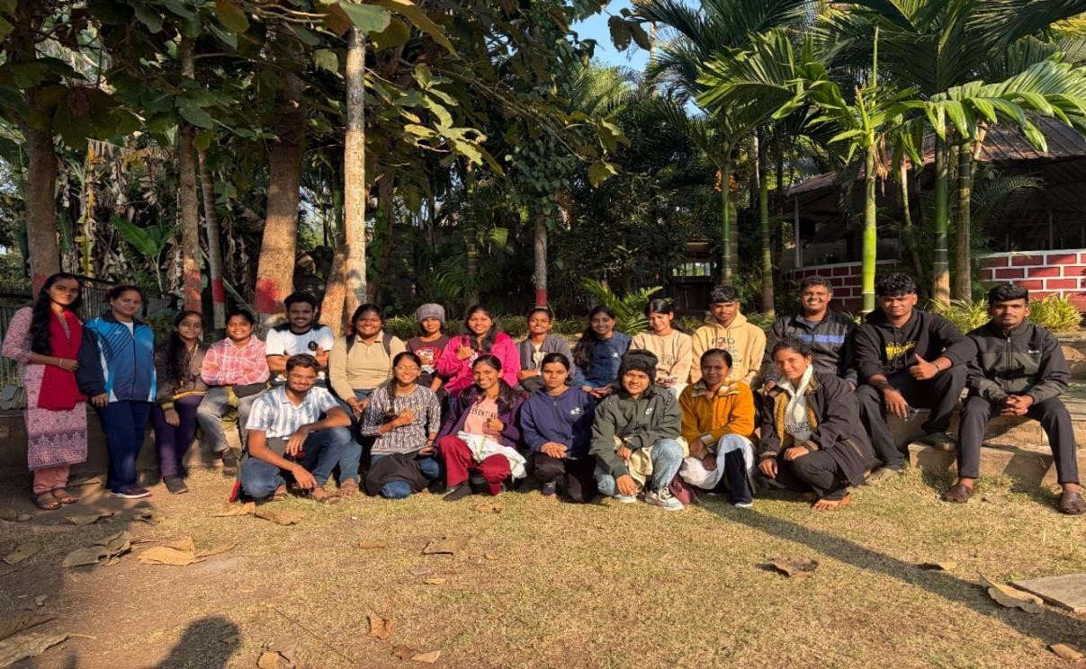
Submitted by: Aadit Ramesh Parab

Class: F.Y.BSc
Roll no: 33

Introduction
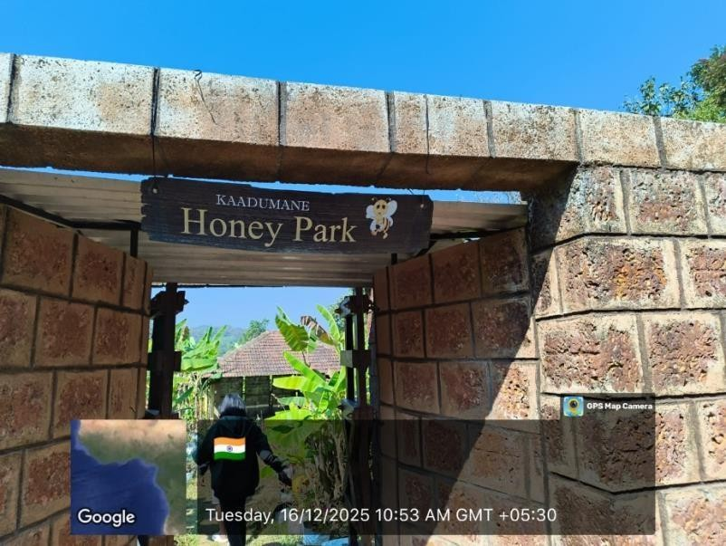

Kadumane Honey Park:
Kadumane Honey Park is a unique ecotourism destination located near Dandeli, Karnataka. It is specially developed to promote awarness about beekeeping (Appiculture) and the importance of honey bee in nature.
The park offers visitors an opportunity to learn about different types of honey, the process of honey extraction, and the role of bees in pollination and biodiversity conservation, surrounded by blush greenery, Kadumane Honey Park combines education, nature, and rural development making it an interesting place for students, tourist, and nature lovers.

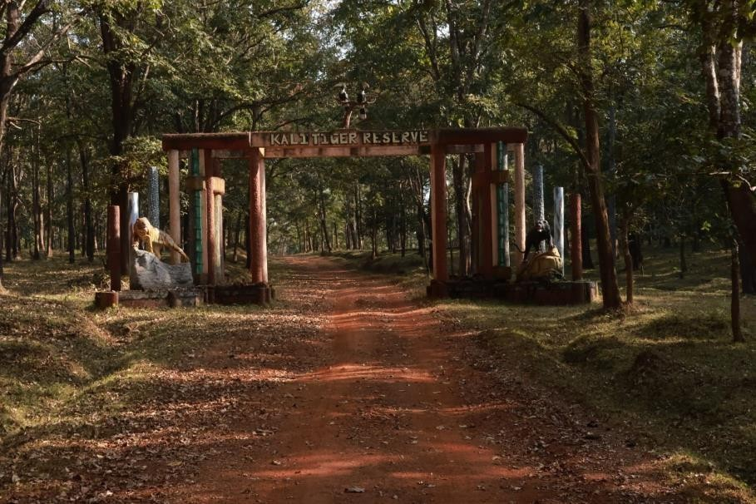

Kali Tiger Reserve:
Kali Tiger Reserve is a famous wildlife sanctuary located in Dandeli, Karnataka. It lies in the beautiful western ghats region and is spread along the banks of the Kali river. The reserve was established to protect the endangered Bengal tiger and to conserve the rich forest ecosystem of the area.
This forest is known for its dense evergreen trees, diverse wildlife, and scenic landscape. It is home to animals like tigers, lepords, elephants, black panthers, deer and many species of birds and reptiles. With its natural beauty and biodiversity, Kali Tiger Reserve plays an important role in wildlife conservation and attracts nature lover
and tourists from all over the India.

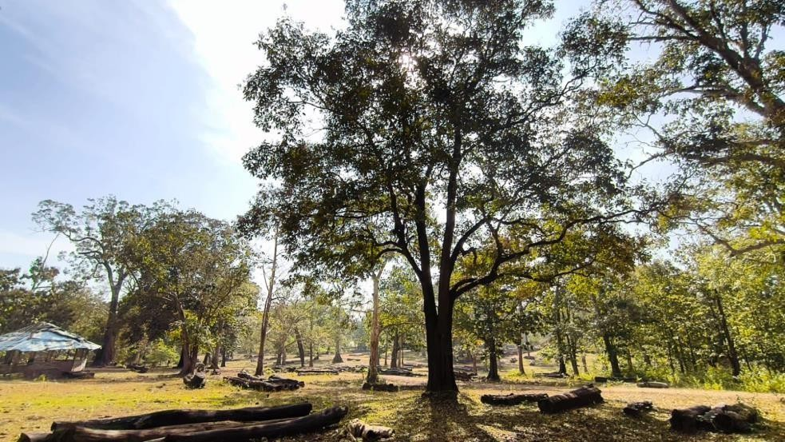

Dandeli Timber Deopt:
The Dandeli Timber Depot is well known forest for timber collection and auction center located in Dandeli, Karnataka. It plays an important role in managing and distributing wood collected from near by forests under government supervision.
Apart from its economic importance, the depot is also popular for bird watching. The tall trees and natural surroundings attracts many birds species, especially hornbills, woodpeckers, kingfisher, and other forest birds. Because of its rich biodiversity, the area around the timber depot has become a favourite spot for nature lover and bird watchers visiting Dandeli.

River rafting and water sports:
Dandeli is one of the most popular adventure destination in Karnataka, especially known for river rafting on Kali river. The fast- flowing river offers exiting white water rafting experiences suitable for both beginners and adventure lovers.
Apart from rafting visitors can also enjoy various water sports such as, Kayaking,
Boating, Zorbing, and Swimming surrounded by lush forest and scenic beauty, Dandeli provides a perfect combination of adventure and nature.

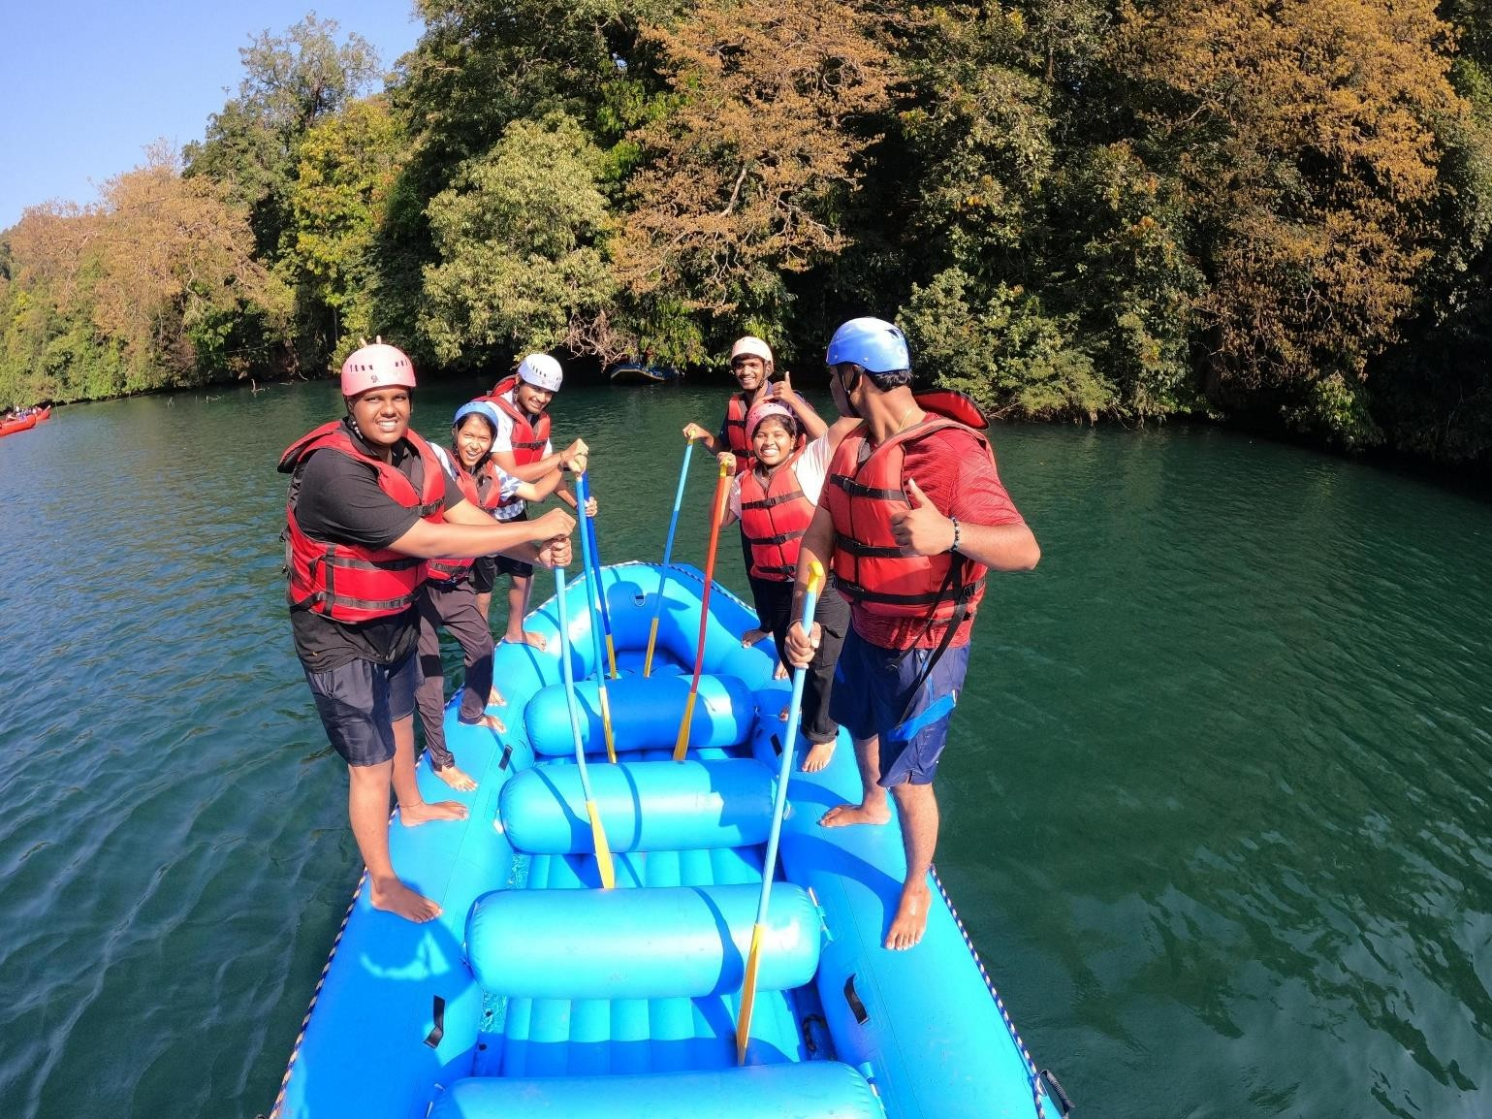

Observation
On 15 to 16 December 2025 a study trip to Dandeli organized by zoology department. At first we went to in our booked resort in Dandeli approximately 150-170km from Kudal, we reached and get freshed and eat breakfast.
Then we visited Kadumane Honey Park, at approximately 10 am. Then we studied and experienced about beekeeping (Appicuture) and get interesting knowledge about bees.
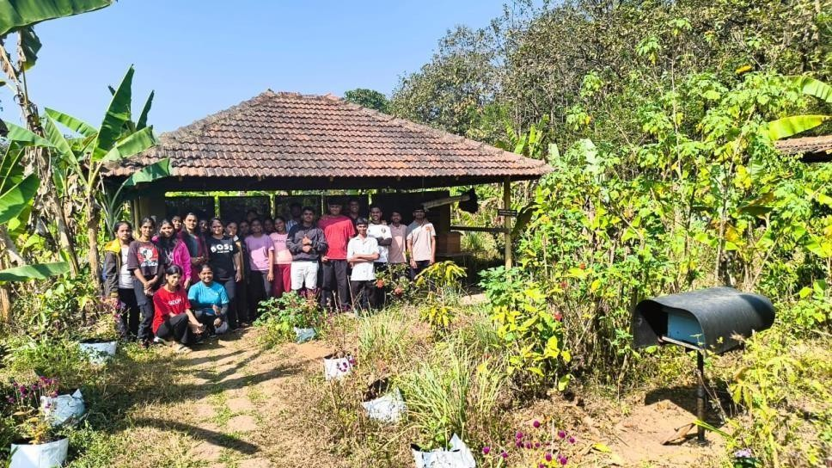

Types of Bee Hive:

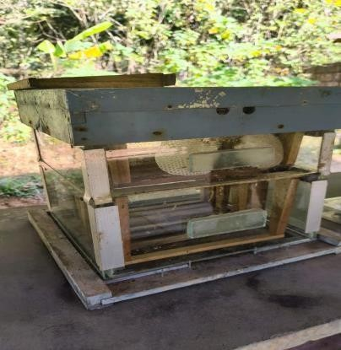
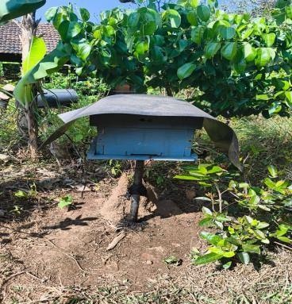
Langstroth Hive
Top – bar hive

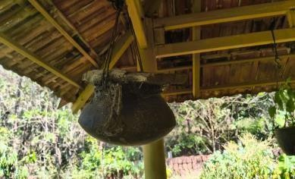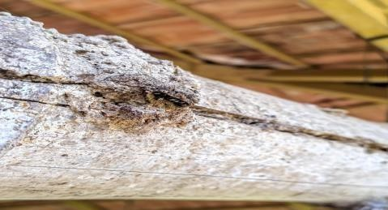
Traditional hive

Extraction machine:
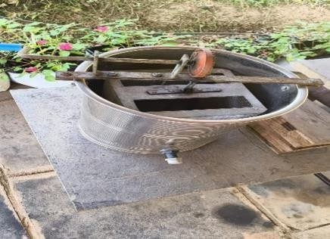
A honey extraction machine is a device used in beekeeping to remove honey from honeycomb frames without damaging the comb.
It works on the principle of centrifugal force. The honey frames are placed inside the drum, and the machine spins, honey is pulled out of the comb and collects at the bottom of the tank
This is the manual extractor: operated by hand.

Byproducts of honey:
When we entered the honey Park, we saw various products created using honey like soaps, dry fruits and honey mixture then original honey and many, then we realise we can also make various products using honey and that are very beneficial for our health, skincare etc.
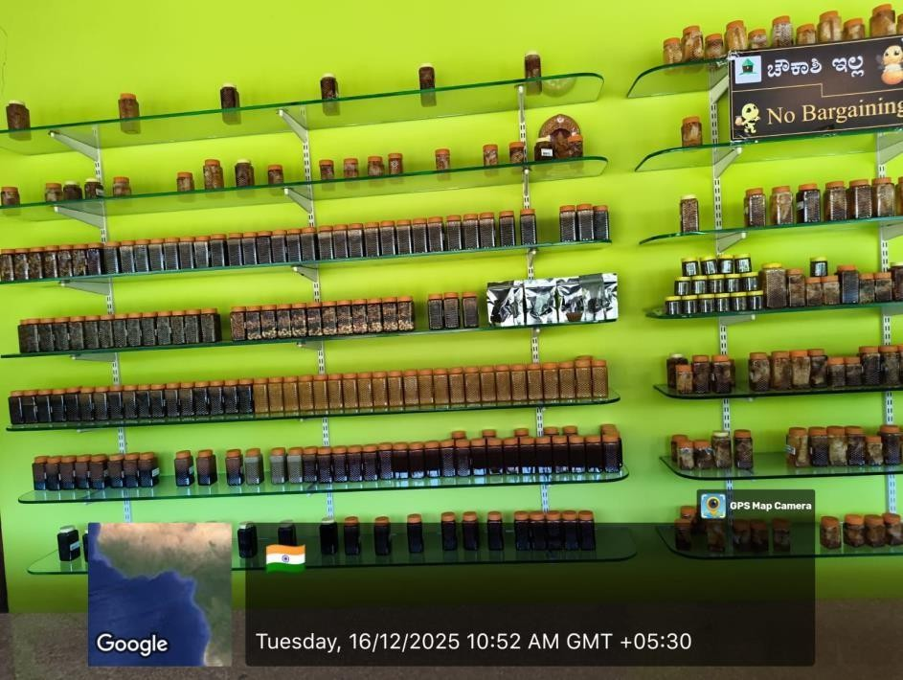

Various honey brand in India:
We saw there are many brands of honey that are made in India.
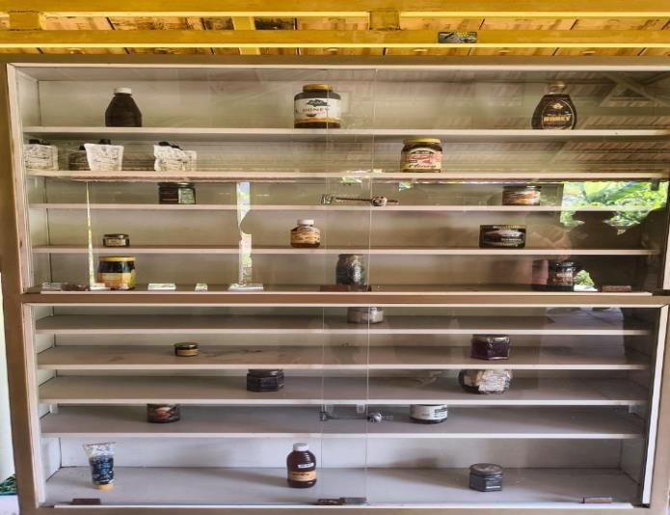

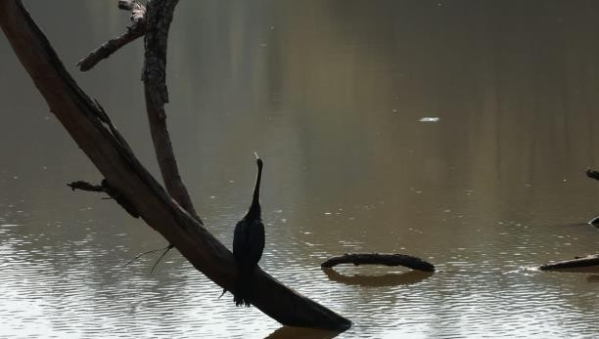
Then we visit the famous Kali Tiger Reserve in Dandeli, with our tour guid and transport jeep we entered the forest and saw many animals, birds, reptiles and the amazing biodiversity.
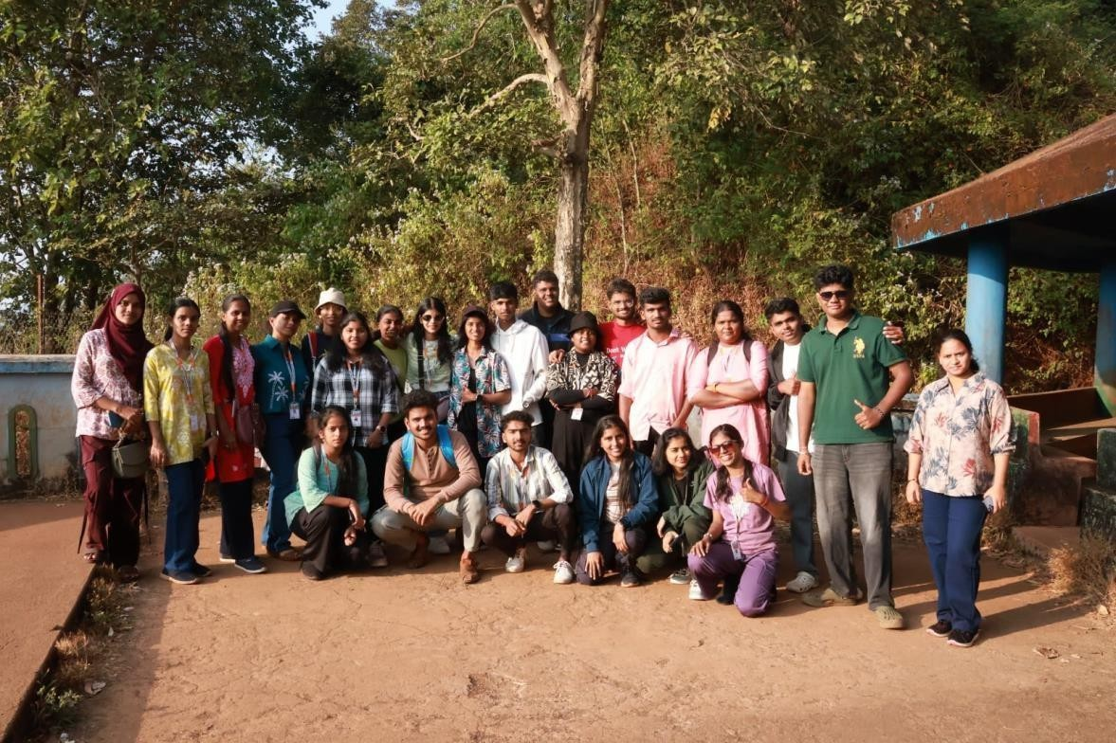

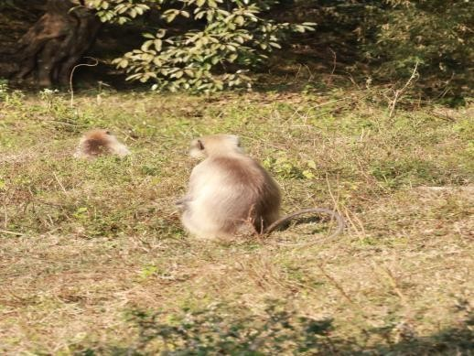
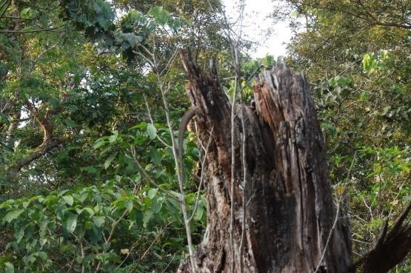

Monkey (around 50-60)

Indian monitor lizard, as they are cold blooded taking sun bath.

We saw 3 types of deer as follows:

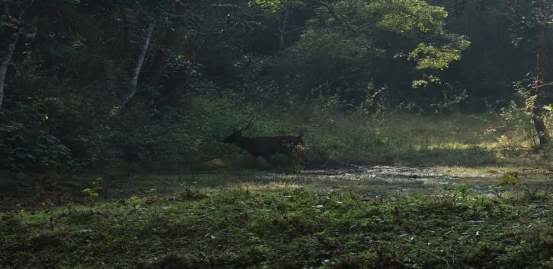

Sambar deer (one)

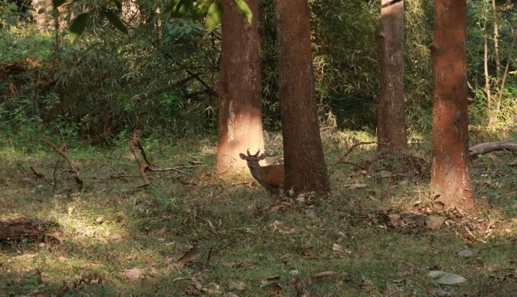
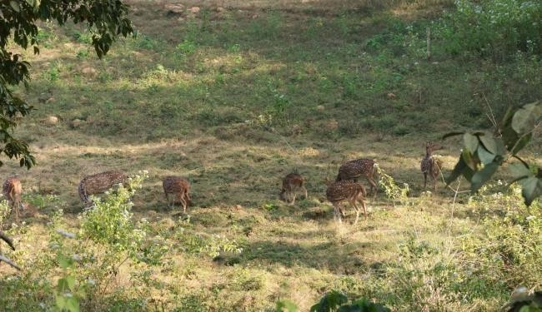

Barking deer (one male and one female at same
spot)

Spotted deer (also commonly called chital, approximately around 20- 25 at a time at same spot.)

Then next day we visit to Dandeli Timber Depto for its amazing biodiversity and especially for bird watching.
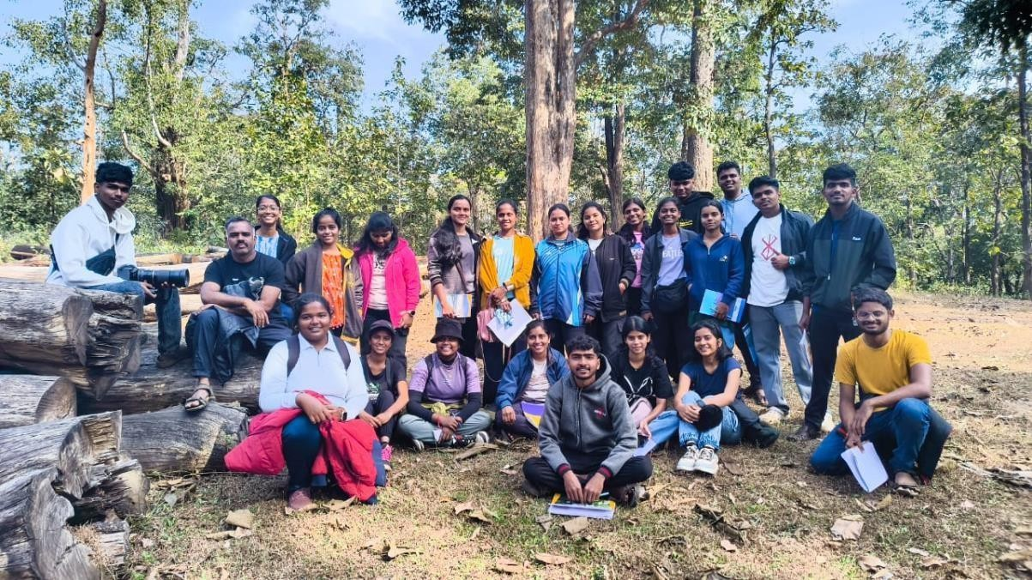

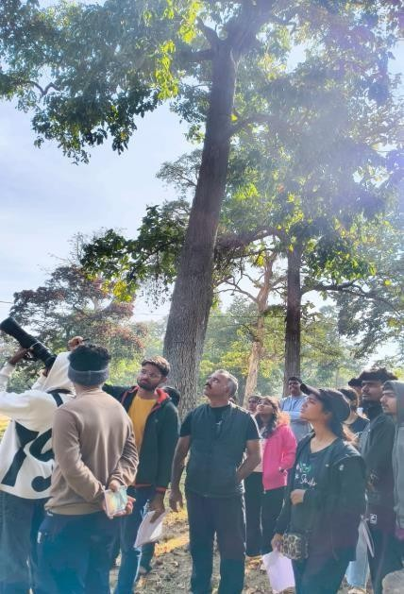

We saw the diversity of birds, moths, butterflies and spiders. Watching and listening their beautiful sound was the wonderful experience. Our guid Dr Yogesh koli sir explained how birds helps in seed dispersal and maintaining the balance of nature.

Sr no | Name of birds, moths, spider etc
1 | Plum headed parakeet
2 | Oriental magpie robin
3 | Indian giant squirrel
4 | Moth (Lymantria todara)
5 | Sun bird
6 | Common jezebel (butterfly)
7 | Ashy drongo
8 | Yellow throated sparrow
9 | Indian nuthatch
10 | Green bee eater
11 | Long tailed wood shrike
12 | White naped woodpecker
13 | Brahminy kite
14 | Cooper smith barbet
15 | Common crow
16 | Tunnel spider

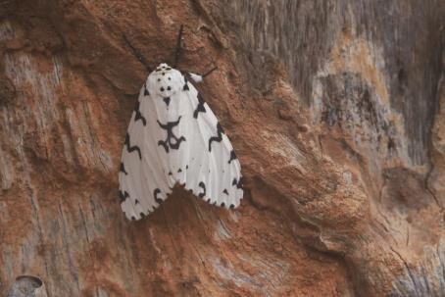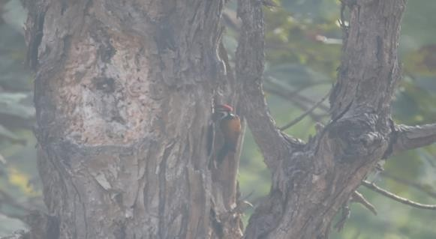

White naped woodpecker
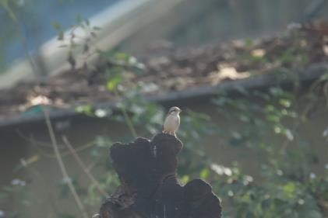
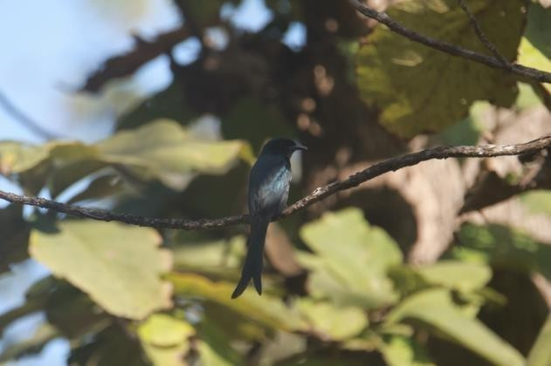

Ashy drongo

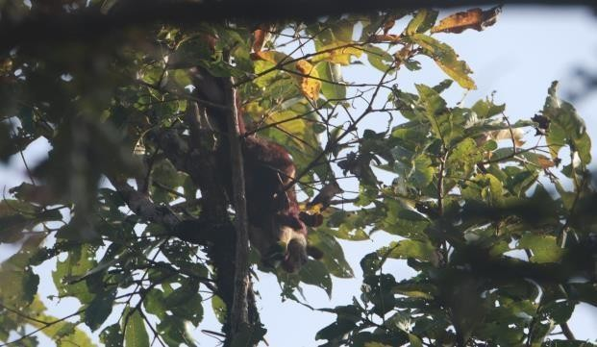

Indian giant squirrel

Conclusion:
Our visit to dandeli was a memorable journey, showcasing diverse species of plants, animals, birds and stunning natural beauty. Our exploration provided valuable insight into the importance of conservation of natural beauty, bee, animals and all over our ecosystems.
We enjoy and explore lot of things, did adventures and made lot of fun and learn many valuable lesson from nature.

